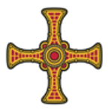
Holy Family
Roman Catholic Parish

Diocese of Hexham and Newcastle

Parish Office
Grosvenor Street
Hartlepool
TS26 8DP

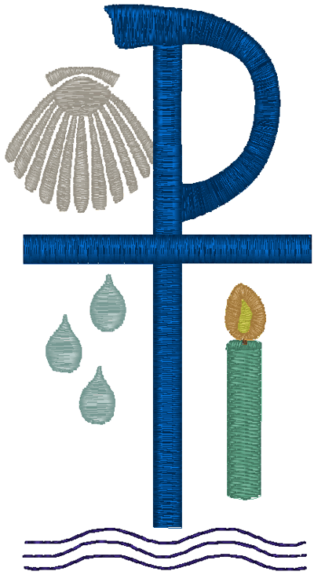
APPLICATION FORM
FOR
INFANT/CHILD BAPTISM

The Sacrament of holy Baptism is the beginning of the whole Christian life, one which is a call to holiness. Baptisms are a regular and essential part of the life of the parish and something we are always very happy to do.
Certain things are necessary to prepare for your child’s baptism:
- Regular attendance (weekly) at Mass
- Attendance at a preparatory session
Please complete and return this form to the Parish Office.
Baptismal Name(s) of child: |  |  |  |  |  |  |  |  |  |  |  |  |  | Boy / Girl
Surname of child: |  |  |  |  |  |  |  |  |  |  |  | Date of Birth: …….… / .……… / ……….
Parents |  |  |  |  |  |  |  |  | Married: Y / N |  |  |  | Maiden name:
Mother: |  |  |  |  |  |  |  |  |  |  | Religion:
Father: |  |  |  |  |  |  |  |  |  |  | Religion:
Address:

Post Code:
Telephone Contact Number(s): |  |  |  |  |  |  |  |  |  | Email Address(es):
Permission of Parish Priest (Non-Parishioners)
If you live outside of the parish, you must obtain the permission of your Parish Priest before making this application.
Parish: |  |  |  | Parish Priest:
I give my permission for the above infant, who is my parishioner, to be Baptised at Holy Family Parish.
Signed:
GODPARENTS

Please read these points carefully before choosing your godparents:
- A godparent is a representative of the Church, standing as a sponsor for the faith.
- A godparent must be a baptised Catholic who has been confirmed and has received first Eucharist, and who lives a life of faith which befits the role to be undertaken; and be no less than sixteen years of age.
- One godparent (male or female) is sufficient, but there may be up to 4 in total.
- A non-Catholic baptised Christian may not be a godparent, but may stand as a Christian witness in company with a Catholic godparent.
- One who is not baptised cannot stand as a godparent or Christian witness.
Godparents:
 |  | Name(s) |  |  |  |  |  |  | Catholic Church of Baptism |  |  |  |  |  | Year of Baptism
Christian Witness:
 | Name(s) |  |  |  |  |  |  |  | Church of Baptism |  |  |  |  |  | Year of Baptism
Baptisms take place on the first and third Saturday of the month at 11.30am and 12.30pm.
Please propose date(s) (Saturdays) and the name of the Church where you would like the Baptism to take place.
The date, time and location will be confirmed at the preparation meeting.

Date(s)
Time: 11.30am / 12.30pm |  |  |  | Church: St Joseph’s / St Patrick’s / St John Vianney’s (Delete as necessary)
The normal stipend for a Baptism is £50. This is an offering to the Minister which helps with expenses, and all other necessary costs enabling us to provide the service. Please bring your offering to the Preparation meeting, as we kindly ask that any donation be made before the service takes place.
Pledged Stipend £…………………………………………………………
If you are unable to make this offering, please speak to the Deacon or Priest at the Preparation meeting.
Information provided in this application, together with all other personal data held about the individuals by the Parish and the Diocese of Hexham and Newcastle, is processed in accordance with the Diocese’s Privacy Notice.
Signed: ……………………………………………………………………………. Date: …………………………………………..
Please sign to confirm that you are aware of the above and approve the retention of the data for this purpose.

For Office Use Only
 |  |  |  |  |  | Date
Provisionally Booked
Preparation Meeting Attended
Stipend Received |  |  |  |  | Y / N
Baptism Slot
Certificate: Y / N |  |  |  |  |  |  |  | Register: Y / N

